**[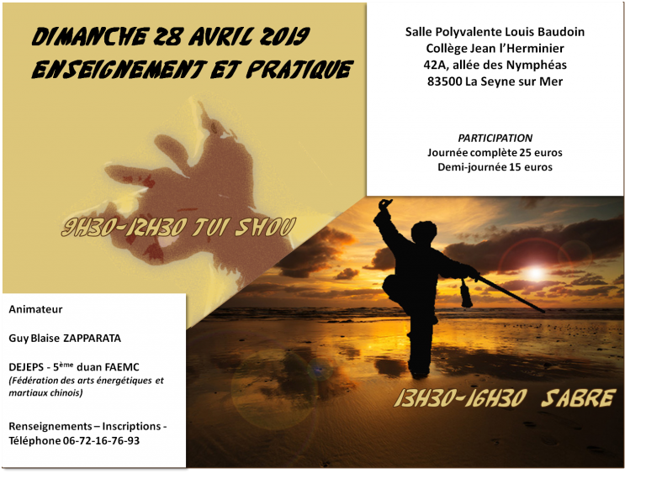](http://www.taichi-etki.com/wp-content/uploads/2019/04/stage-guy.png)**