**[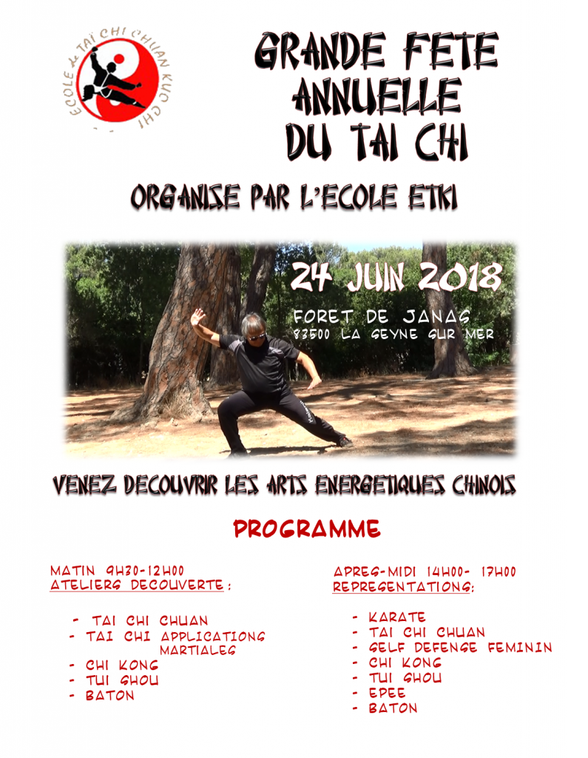](http://www.taichi-etki.com/wp-content/uploads/2018/06/Image1.png)**